Facilities, Equipment, and Other Resources

UCI SAMUELI SCHOOL OF ENGINEERING SHARED FACILITIES
(note: Shorter text also provided at the end)
Irvine Materials Research Institute (IMRI)
IMRI operates university-wide shared user facilities that offer a wide range of materials characterization instrumentation and techniques including Transmission Electron Microscopes (TEM); Scanning Electron Microscopes-Focused Ion Beam systems (SEM-FIB); X-ray Diffractometers (XRD); surface analysis; 3D imaging and analysis; and thermal, elemental, mechanical, physical and rheological property measurements, together with comprehensive specimen preparation facilities. IMRI provides training and staff support. On-site users reserve instrument time on the IMRI website. IMRI staff includes seven Ph.D. level scientists who oversee all activities within the IMRI facility.
Within IMRI, there are three user facilities: 1) Center for Transmission Electron Microscopy (CTEM); 2) Laboratory for Electron and X-ray Instrumentation (LEXI); and 3) Thermal, Elemental, Mechanical, Physical and Rheological (TEMPR) facility. The capabilities and unique characteristics of the instruments with in these facilities are summarized as follows:

1) Center for Transmission Electron Microscopy (CTEM)
a) Nion aberration-corrected UltraSTEM 200 with a monochromated EELS system (HERMES 200)
Nion HERMES 200 has the highest spatial and energy resolution of any commercially available STEM, with many critical features not found on any other instrument. The unique design of the monochromator of the HERMES system provides an energy resolution for electron energy loss spectra (EELS) of 5.7 meV when operated at 60 kV and 4.2 meV when operated at 30 kV, with a long-term energy stability of the order of 10 meV/min. This allows vibrational spectroscopy to be carried out in combination with the spatial resolution and flexibility of the TEM. Thus, this unique microscope can explore physical phenomena such as lattice vibrational modes (phonon) and chemical-bond vibrations that are spatially highly localized. Besides the monochromator, HERMES also includes an advanced aberration corrector unavailable on any other instrument, which allows individual control of all aberrations up to fifth order, providing the unprecedented STEM spatial resolution of <0.5 Å when operated at 200 kV. The Nion HERMES enables researchers to explore the atomic structure, chemical bonding, and local electronic structure of materials with the highest spatial and energy resolution in combination with ultrahigh energy resolution for EELS. It is equipped with high angle annular dark field (HAADF), medium angle annular dark field (MAADF), annular bright field (ABF), and wide/small angle bright field (BF) detectors and an advanced electron energy-loss spectrometer. The Nion UltraSTEM is the only electron microscope that operates in ultrahigh vacuum conditions (<10⁻¹⁰ Torr). Thus, electron beam induced contamination is avoided and samples such as graphene and other 2D materials are largely stable when imaged and analyzed at an energy less than their knock-on displacement threshold.
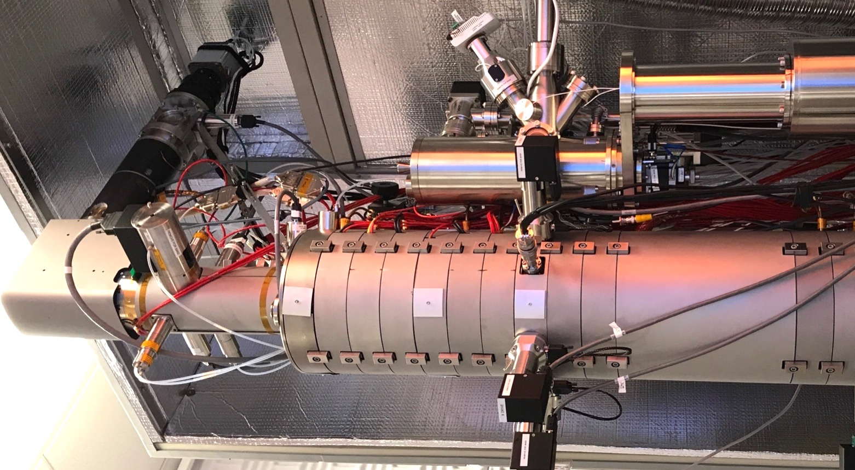
NION HERMES 200 has a spatial resolution of better than 0.5 Å when operated at 200 kV and an energy resolution of 5.7 meV at 60 kV and 4.2 meV at 30 kV for high performance EELS.
The JEOL JEM-ARM300F TEM (Grand ARM) equipped with a K2 IS camera provides tools for the ultrahigh spatial resolution TEM imaging and spectroscopy of nanostructured materials.
b) JEOL double spherical aberration-corrected JEM-ARM300CF “Grand ARM”
The Grand ARM is the newly introduced JEOL 60-300 kV TEM, which offers 63 pm resolution at 300 kV for atom-by-atom characterization and chemical mapping. It features JEOL-proprietary spherical aberration correctors integrated in the image-forming system and illumination system, and an ultra-stable cold-cathode field emission electron gun. The cold field emission gun provides a high probe current in a very small probe with an energy resolution of 0.35 eV, which is ideal for the structural and chemical analysis of nanostructured materials, defects and devices with atomic resolution. The wide pole piece gap (>6 mm) of the JEM-ARM300FC makes it possible to develop customized holders for a variety of in-situ TEM experiments to study the structure, properties, and dynamic behavior of nanostructured materials under applied fields, stress, and reactive environments. The Grand ARM uses a unique hybrid high-angle annular dark field (HAADF) STEM detector. This detector provides a sensitivity higher than any scintillator over the entire accelerating voltage range, from 300 kV to 60 kV or less. Higher sensitivity means better signal to noise ratio, which is important for imaging under low beam current for beam-sensitive samples such as soft and 2D materials. This microscope is equipped with a dedicated annular bright field (ABF) detector, which makes ABF imaging easy, by just inserting the detector. There is no need to change camera lengths to adjust what is being collected on the standard bright field (BF) detector. This allows one to acquire HAADF, ABF and BF images simultaneously over a range of camera lengths. This capability is critical for atomic scale structure and property analysis of materials containing both light and heavy elements. Alignment of the imaging and probe-forming correctors uses a special, easy-to-use algorithm (no standard sample is needed). The Grand ARM is integrated with a new generation direct electron detection system (the Gatan K2 IS) and the newly released OneView cameras for optimum CCD imaging. The K2 IS is the most powerful camera available for TEM imaging, a game changer for electron microscopy, that enables the study of atomic scale details of structural changes dynamically within TEM (up to 1600 fps). This microscope is also equipped with an electron biprism for holography, double 100 mm² X-ray detectors for energy-dispersive spectroscopy (EDS) and the Gatan 965 GIF Quantum ER imaging filter with dual energy range EELS (DualEELS), suitable for the rapid mapping of elements with atomic resolution.
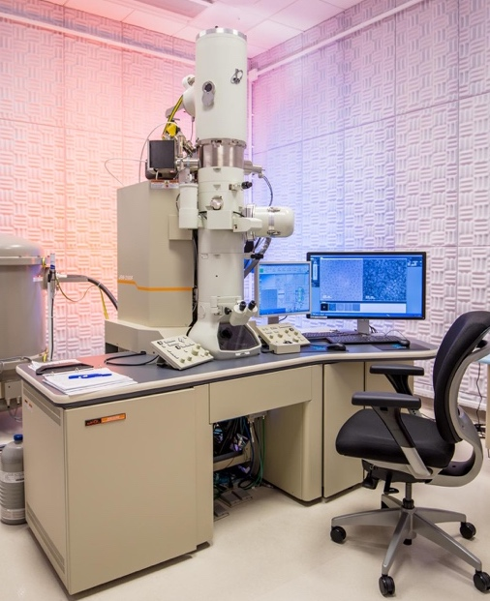
JEOL JEM-2100F cryo TEM equipped with K2 summit camera.

c) JEOL JEM-2100F Cryo-TEM
This 80-200 kV TEM is equipped with a field emission gun, a cryo stage, and a Gatan CCD camera (OneView) and a K2 Summit camera for the study of biological specimen at room and liquid nitrogen temperatures. The cryo TEM is suitable for observation of frozen hydrated specimens such as single proteins or two-dimensional crystals of membrane proteins. This microscope is equipped with a differential vacuum system utilizing sputter ion and diffusion pumps, eucentric motorized 5 axis side entry goniometer with a cryo pole piece which provides a point-to-point resolution of 0.27Å with specimen tilting up to ±60°. A double-tilt cryo-transfer system (Gatan 915) allows frozen sections or suspensions to be loaded into the holder and transferred frost-free at temperature lower than -170°C. This system includes a double tilt, liquid nitrogen cooled specimen holder and tools for frost-free transfer of up to four grids. There is also a second double-tilt liquid nitrogen cryo holder with beryllium cradle (Gatan 626) for a range of frozen samples. One can utilize the cryogenic and atomic level structural analysis capabilities of the cryo TEM to examine biological materials, large molecules, and medical biopsy samples.
JEOL JEM-2800 high-throughput TEM equipped with dual large angle SDD EDS detector (100mm), making rapid EDS mapping possible.
d) JEOL JEM-2800 S/TEM
This versatile 100-200 kV Schottky field emission TEM will serve as a workhorse for structural/chemical analysis of materials. It features high resolution imaging in TEM, STEM, HAADF, ABF, and secondary electron (SE) modes (analytical high-resolution pole piece), ultrasensitive elemental mapping with large angle EDS (dual dry solid-state 100mm² detectors), and the Gatan OneView IS camera for imaging and in-situ observations at 320 fps. The JEM-2800 has fully automatic functions including adjustment of focus, astigmatism, contrast, brightness, crystal zone axis alignment, and specimen height. Switching between analysis modes is seamless, and quick data collection shortens turnaround time between samples. An operator navigation system and on-screen operating guide make the JEM-2800 a high throughput, user-friendly TEM for any skill level.

e) TESCAN GAIA-3 XMH integrated focused ion beam-FESEM
The GAIA-3 XMH FIB-SEM is TESCAN’s newest, highest-end flagship dualbeam instrument. It has a unique three-lens electron optical design capable of dedicated modes for extreme high-resolution imaging (magnetic immersion mode), enhanced depth of focus, undistorted ultra-low magnification imaging, and live 3D stereo imaging. These unique features will provide ease of use to the multi user environment, especially for our students and young researchers. The instrument is fully equipped with beam deceleration, in-beam SE and BE detectors, retractable STEM and YAG BE detectors, off-axis Everhart-Thornley SE detector, SITD secondary ion detector, 5-reservoir gas injection system (W, Pt, SiO_{x}, H₂O, XeF₂), in-situ plasma cleaner, electron beam lithography package, autoslicer, 3D Tomography Advanced package, electron beam induced current (EBIC) system, Oxford AZtecEnergy Advanced EDS Microanalysis System with the latest X-Max 150 mm² silicon drift detector, Oxford AZtecHKL Advanced NordlysMax2 integrated EBSD System, and Omniprobe 400 port-mounted piezo nanomanipulator, the last of which provides an ideal tool for the preparation of TEM specimens for structural imaging and chemical analysis with atomic resolution in combination with the state-of-the-art TEMs described above. The smart chamber design of the GAIA XMH FIB-SEM instrument allows for the simultaneous milling and collection of EBSD patterns without the need to move the sample. This flexibility is unique to TESCAN and will provide best-in-class accuracy and throughput for EBSD and EDS. The 3D-EDS and EBSD reconstructions are critical for understanding the structure and chemistry of materials. This FIB-SEM is the only such system that can be integrated with a time of flight secondary ion mass spectrometer (TOF-SIMS), which is planned for the future.
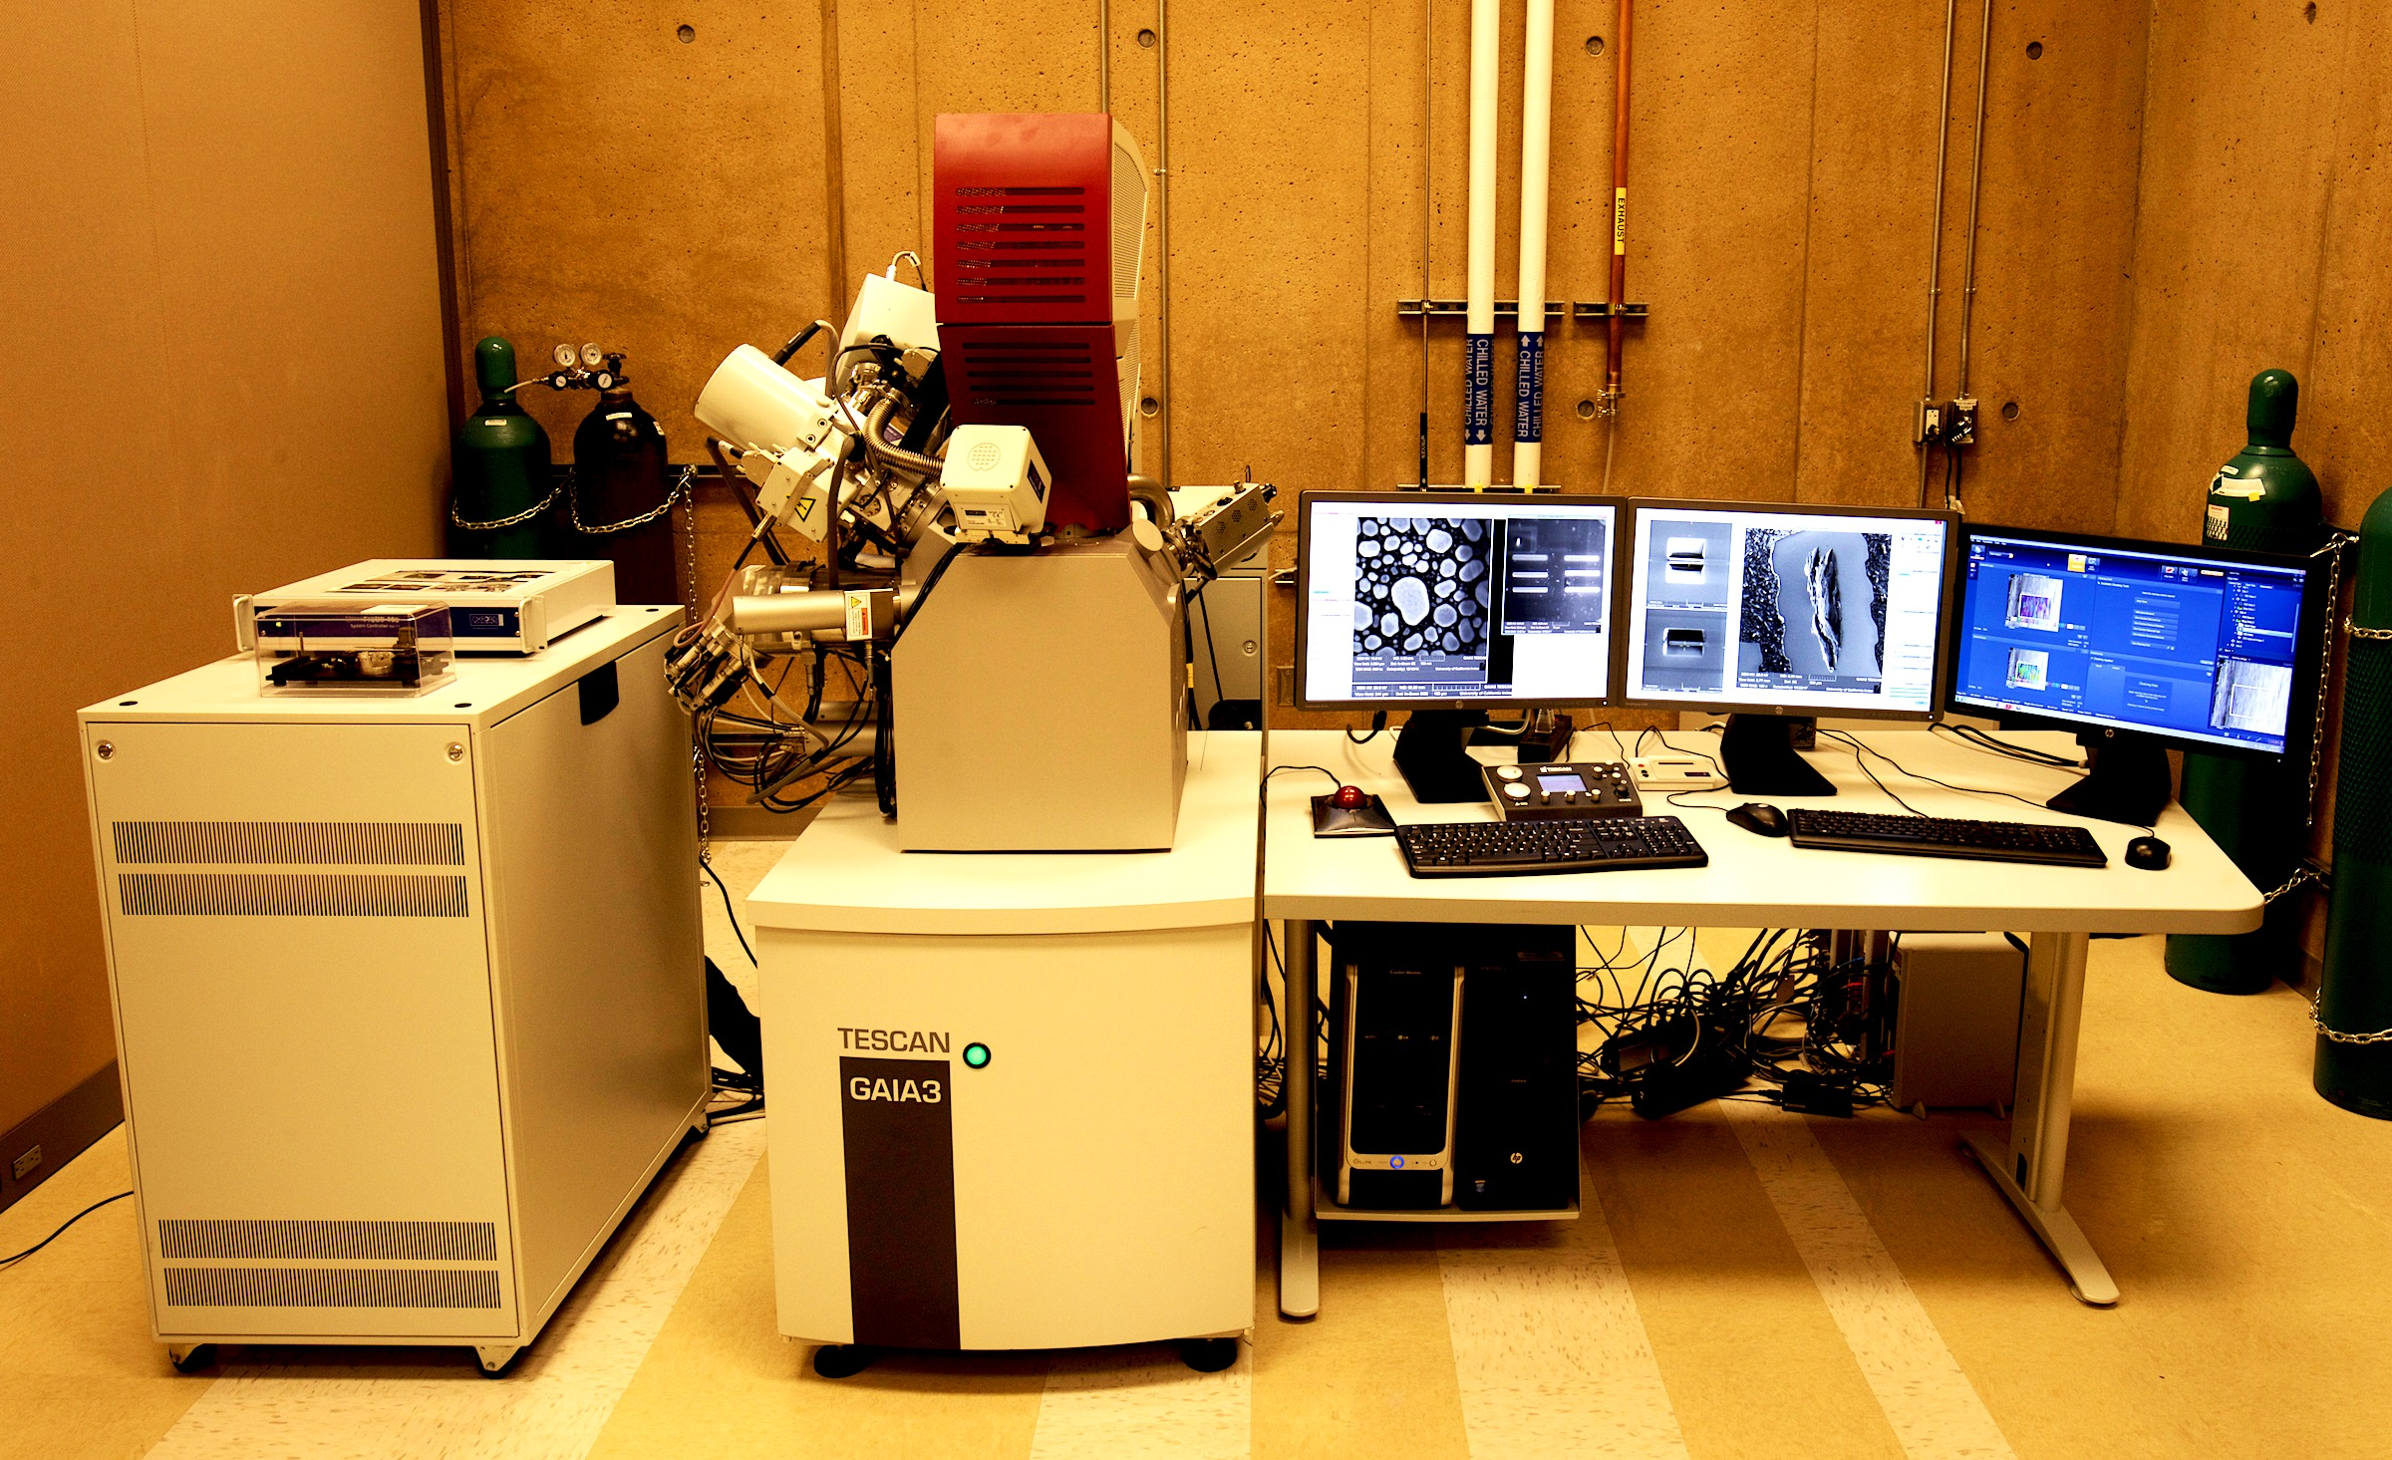
TESCAN GAIA-3 GMH integrated focused ion beam-FESEM.

f) A variety of TEM holders are available, including in-situ holders. These include:
- multiple low background single-tilt and double-tilt holders
- double-tilt liquid nitrogen cooling holder (Gatan 626)
- double-tilt cryotransfer system (Gatan 915)
- double-tilt 1000°C heating holder w/ tantalum (Gatan 652)
- Hummingbird scientific tomography holder and corresponding data acquisition and analysis software packages for both TEM and STEM
- Hummingbird nano-manipulator in situ electrical biasing holder (STM plus electrical feedthroughs)
- Hysitron PI 95 TEM PicoIndenter
- Gatan’s Heating Straining Holder (customized order)

2) Laboratory for Electron and X-ray Instrumentation (LEXI)
Laboratory for Electron and X-ray Instrumentation (LEXI) was established in 2009. LEXI houses 6 new major instruments together with a full set of sample preparation equipment and provides strong capabilities for sub-nanometer surface imaging, cross-section imaging, environmental SEM imaging, electron back-scattering imaging and diffraction, composition analysis, grain orientation analysis, electron beam and ion beam lithography, nano-scale electrical probing, crystal structure determination, texture study, phase transformation study, MEMS in-plane and out-plane vibration study and various metal depositions.
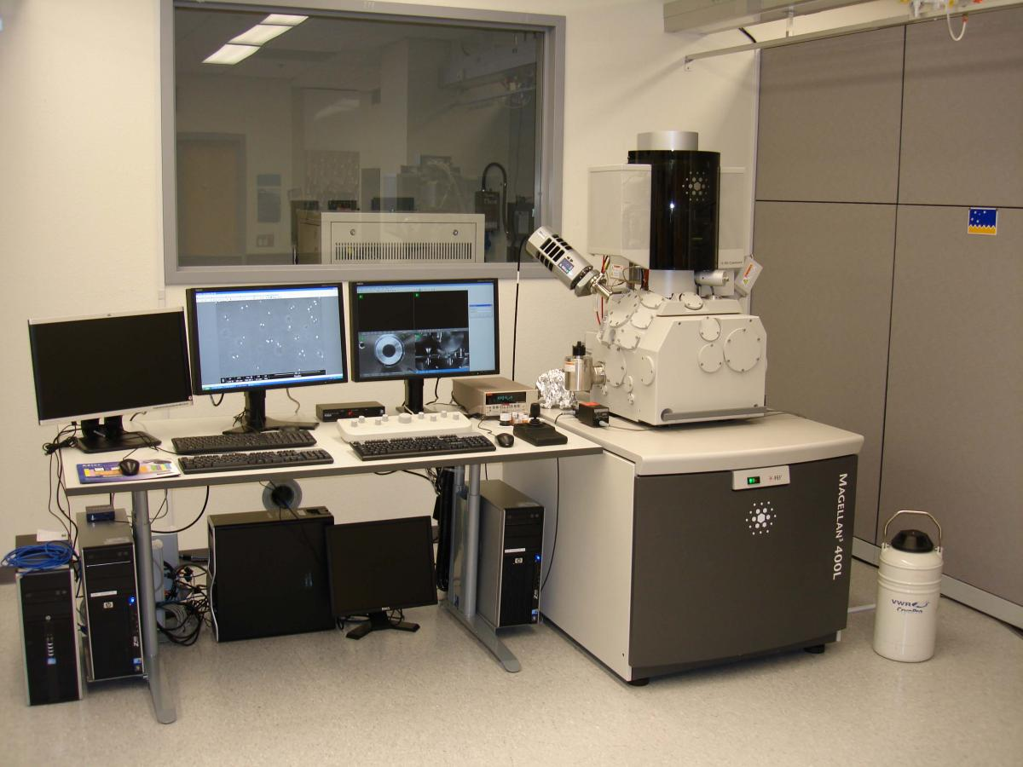
FEI Magellan 400 SEM

a) The FEI Magellan 400 SEM
The FEI Magellan SEM is an extreme high-resolution scanning electron microscope equipped with a new monochromated electron column, beam deceleration, in-lens secondary electron detector, both in-lens and retractable back-scattering electron detectors, STEM detectors, electron beam lithography package, large EDS detector, in-situ 4-probe system and in-chamber plasma cleaner. This SEM enables sub-nanometer resolution and high surface sensitivity at low landing energies, and is capable of light element analysis, fast elemental mapping, electron beam lithography, low voltage (15-30kV) STEM and nano-scale electrical measurement.
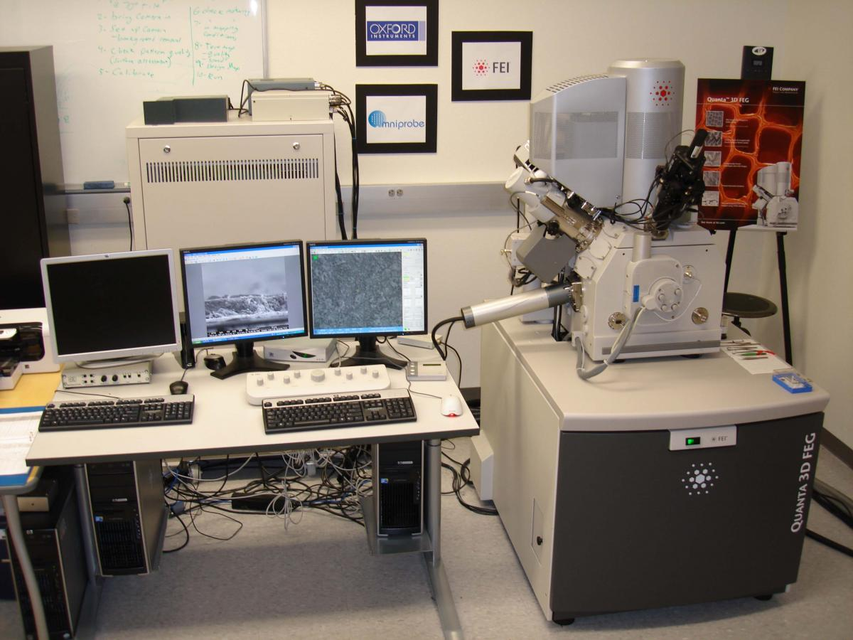
FEI Quanta 3D FEG

b) FEI Quanta 3D FEG dual-beam SEM/FIB
The FEI Quanta is a dual-beam (SEM/FIB) instrument with different imaging modes. It is equipped with an EDS system, EBSD system, cooling stage, beam-deceleration, OMNI probe, and Pt gas injection system. It is capable of high-resolution surface imaging (1nm resolution at 30kV), fast composition analysis, crystal structure determination, orientation mapping, micromachining, ion beam lithography, Pt deposition, and TEM specimen preparation. It may be operated under different vacuum modes, for example, high vacuum, low vacuum and environmental (ESEM). Either dry inorganic samples or hydrated biological samples can be observed in this instrument.

c) Rigaku SmartLab XRD
The Rigaku SmartLab is the state-of-the-art highly automated, fully modular, multipurpose X-ray diffractometer. This fully-loaded system features a 2.2 kW Cu tube and a high-resolution closed loop theta-theta vertical goniometer with a horizontal sample stage and a 6-position automatic sample changer. Rigaku's patented cross beam optics (CBO) allows rapid switching between parafocusing geometry for powder samples and parallel beam geometry for thin films and epilayers. The system incorporates SAXS optics for measuring structures with d-spacings up to 100 nm in either transmission (spinning capillary) or reflection (GISAXS) mode. A CBO-f polycapillary optics attachment is available to create a high-intensity point focus of 100 microns for micro-diffraction experiments. An in-plane diffraction attachment provides an additional detector scanning axis orthogonal to the theta/2-theta diffraction plane to allow measurement of lattice planes perpendicular to the sample surface (e.g., in-plane reciprocal space maps and full pole figures). Four incident beam monochromators {Ge(220) 2-bounce, Ge(220) 4-bounce, Ge(400) 2-bounce, Ge(440) 4-bounce} and two analyzer monochromators {Ge(220) 2-bounce and Ge(400) 2-bounce} enable medium and high resolution X-ray diffraction and reflectivity measurements of highly perfect crystals, epilayers, and multilayer samples with up to 5 arc second resolution. The system's Anton Paar DHS domed hot stage can be used for in situ measurements of samples in vacuum, air, or inert gas up to 1100°C. A second furnace stage offers in situ capability in vacuum, air, or inert gas up to 1400°C. The SmartLab is outfitted with three detectors for maximum versatility and speed: a point scintillator, a 1D D/teX Ultra high-speed silicon strip detector, and a 2D CMOS Pilatus area detector (module size: 83.8 × 33.5 mm²). The most novel feature of SmartLab is the control software, called "SmartLab Guidance." It can provide an intelligent interface to guide users to select optimal hardware configurations and provides fully automated optics alignment, sample alignment, slit and scan condition settings, and measurements, which helps to minimize the time-to-results for all users. Measurement packages are available for nearly any conceivable X-ray scattering experiment, including the following:
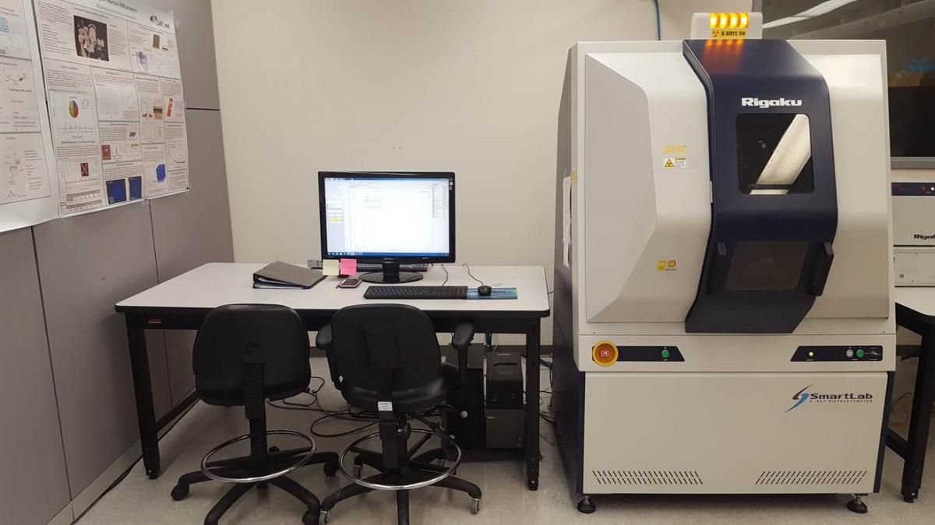
Rigaku SmartLab XRD
- Powder materials: phase ID, crystalline strain and size, crystallinity, structural analysis and refinement, stress measurement, temperature-dependent in situ phase evolution to 1400°C in controlled or ambient environment;
- Thin films: Structural analysis, texture analysis, in-plane diffraction, crystal quality analysis (rocking curve and reciprocal space mapping), high resolution X-ray diffraction and reflectivity (HRXRD and HRXRR), GIXRD depth profiles, 2D stress and PF measurement, temperature-dependent in situ phase evolution up to 1100°C in controlled or ambient environment.
- Small-angle X-ray scattering (SAXS): particle/pore size distribution and correlation length analysis, nanoscale structural analysis containing atoms and molecular, structure and dynamics of biological macromolecules, liquids.
- Microdiffraction: XRD with the ability to precisely and accurately position a small X-ray beam (down to Ø100 µm size) on a small sample,100x100 mm² diffraction function mapping (DFM).

d) Rigaku Ultima III XRD
The Rigaku Ultima III is a versatile X-ray diffraction system equipped with a high precision horizontal sample stage and a cross beam optics system to permit either high resolution parallel beam with a motor controlled multilayer mirror or Bragg-Brentano para-focusing beam geometries. The Ultima can perform high throughput material analysis and discovery tasks by combining an automatic sample exchanger (ASC-10) with a high-performance one-dimensional D/teX Ultra detector that provides up to 100x intensity gain compared to conventional 0D scintillation counters. Curved/flat graphite and germanium crystal monochromators are available for high resolution XRD measurements. An in-plane arm maximizes the system configuration options for a wide range of measurements.
The Ultima III diffractometer enables a variety of powder and thin film measurements, including high resolution powder X-ray diffraction for phase identification, quantitative analysis, lattice parameter refinement, crystallite size, structure refinement, and residual stress. The advanced thin film attachments enable precise sample alignment for X-ray reflectivity for thickness density and roughness analysis, grazing-incidence X-ray diffraction for depth-controlled phase identification, epitaxial film perfection and structure analysis using reciprocal space mapping and rocking curve measurements. It is also able to perform small angle X-ray scattering for particle/pore size and shape analysis. A complete set of database and analysis software is available on the workstations associated with this upgraded Ultima III system.
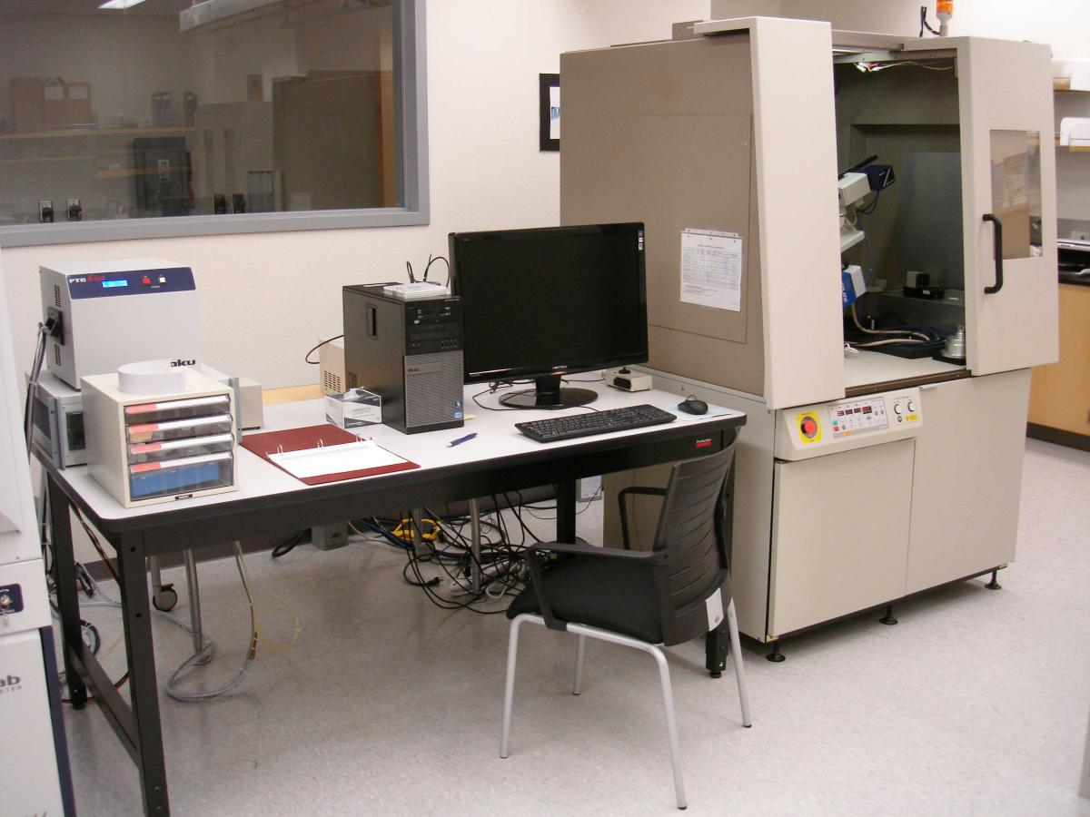
Rigaku Ultima III XRD

e) The Polytech MSA-500 Micro System Analyzer
The Polytech Microsystem Analyzer (called the "Vibrometer") is a fully integrated Structural Dynamics and Surface Metrology System. In simple terms, this instrument focuses one beam of laser light on a spot in the sample in order to accurately track the position and velocity of that point. The entire surface of the sample can be scanned, with unprecedented speed and resolution. The accompanying software collects and elaborates the information. Three main quantities can then be accurately measured:
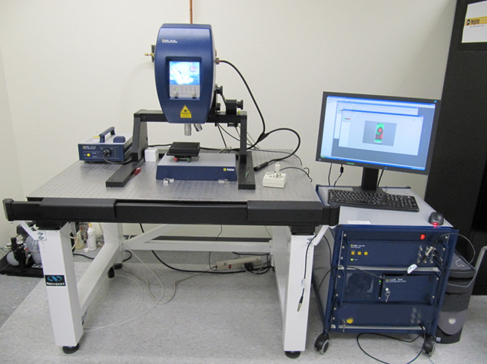
Polytech MSA-500 Micro System Analyzer
- Surface topography (i.e. the z-coordinate of each point in a surface) with sub-nanometer resolution.
- In-plane deformation and vibration modes, with nanometer amplitude resolutions and at frequencies up to 1MHz.
- Out-of-plane deformation and vibration modes, with picometer amplitude resolutions and at frequencies up to 24MHz (extendable to 600MHz with an optional add-on (not included)).
- These functionalities are achieved by incorporating three separate non-contact measurement technologies into one piece of equipment: (i) white-light interferometry, enabling surface metrology and topography reconstruction; (ii) laser-Doppler vibrometry, enabling real-time out-of-plane vibration analysis; and (iii) stroboscopic video microscopy, enabling real-time in-plane vibration analysis. Importantly, optically transparent liquid media don’t interfere with the laser beam, allowing characterization of samples in aqueous solutions. At the same time, position and velocity at surfaces of transparent objects can be measured, provided the surface introduces a sufficient discontinuity in the refractive index. This extends the applicability of this tool to microfluidics and biological research.
f) Angstrom Engineering EvoVac glovebox-integrated thermal and electron beam evaporator
The Angstrom Engineering glovebox-integrated evaporator is capable of depositing planar and nano/microstructured thin films of a wide range of materials, including metals, oxides, and organics. Its key features include the following:
- 6-pocket electron beam evaporation source and 3 thermal evaporation sources with integrated shutters, multiple deposition rate monitors, and co-deposition capability.
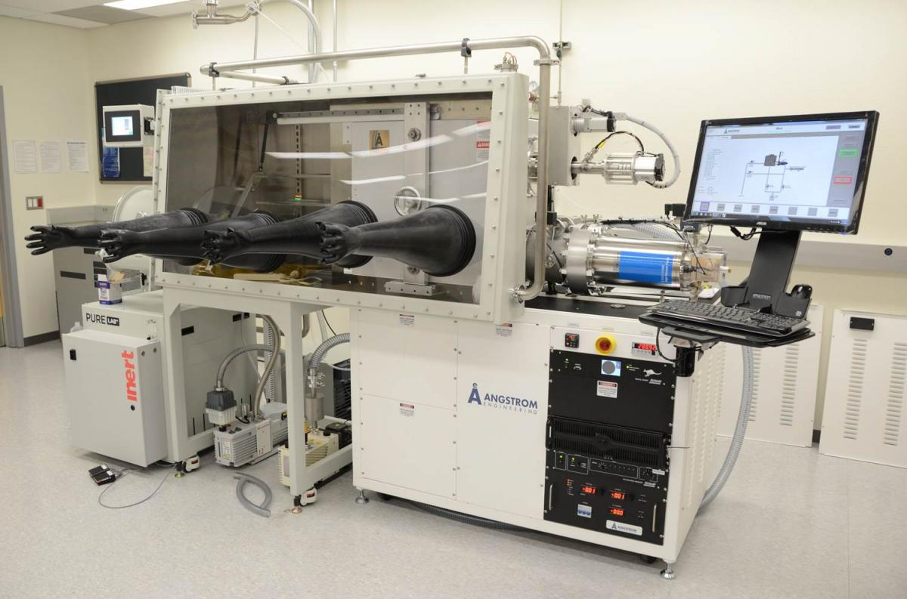
Angstrom Engineering EvoVac glovebox-integrated thermal and electron beam evaporator
- Variable angle substrate stage (0.1 degree tilt angle precision; up to 6 inch diameter wafers) appropriate for glancing angle deposition (GLAD) technique for fabricating nanostructured thin films.
- Substrate heating to 400C.
- Integrated 4-glove glove box for manipulating/loading air sensitive samples.
- Excellent automation and software control of multi-step deposition recipes.

3) Thermal, Elemental, Mechanical, Physical and Rheological (TEMPR) Facility
The newly established TEMPR Facility (mid-2019) is a world-class shared laboratory for the physical property characterization and elemental analysis of bulk and thin-film biological, soft, and hard materials. The facility houses a suite of state-of-the-art characterization instruments capable of measuring materials thermal, elemental, mechanical, physical, and rheological properties. Each measurement category is summarized below:
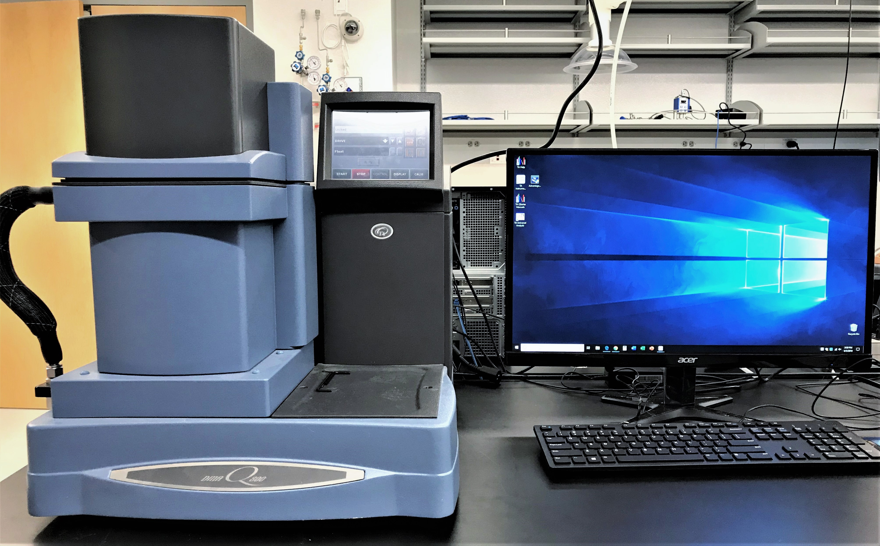
TA Instruments Dynamic Mechanical Analyzer Q800
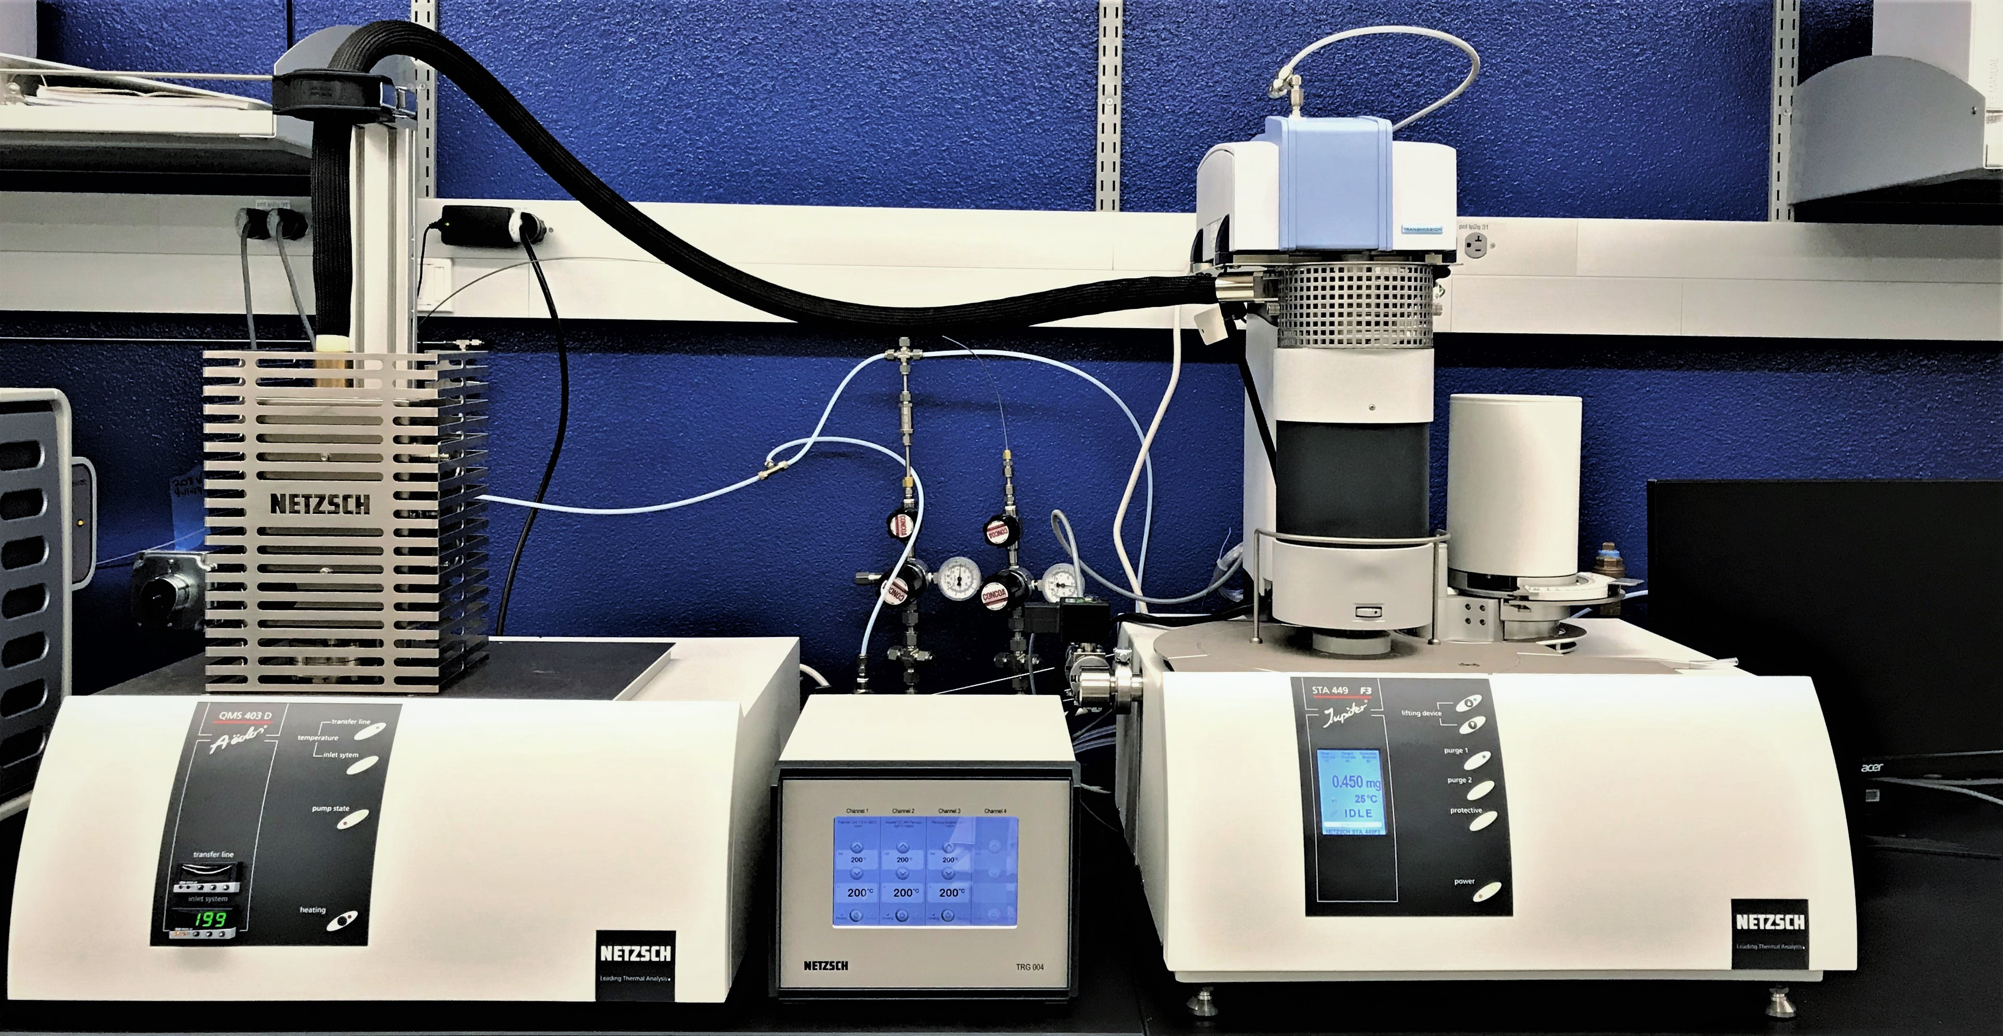
NETZSCH STA 449 F3 Jupiter® with FT-IR and mass spectrometer
a) Thermal Property Measurements: Three differential scanning calorimeters (TA Instruments DSC Q2000, Discovery DSC 2500, and Netzsch DSC 214 Polyma®) provide versatile materials phase transition measurements from -90 to 600 °C. In particular, Discovery series DSC 2500 is equipped with a new Fusion Cell™ for high sensitivity, resolution, reproducibility, and reliability. A linear autosampler allows for worry-free 24/7 operation. Modulated DSC® technology enables efficient separation of complex thermal events. Two thermogravimetric analyzers (Netzsch TG 209 F1 Libra® and TA Instruments TGA Q500) are capable of measuring materials mass changes at temperature from ambient condition up to 1100 °C with resolution of 0.1 µg. A simultaneous thermal analyzer NETZSCH STA 449 F3 Jupiter® allows for measurement of both mass changes and thermal effects up to 1600 °C from a single sample run. An in-line coupled system of a Bruker ALPHA II Fourier transform-infrared (FT-IR) spectroscopy and a QMS 403 D Aëolos® quadrupole mass spectrometer offers comprehensive evolved gas analysis for materials decomposition or desorption.
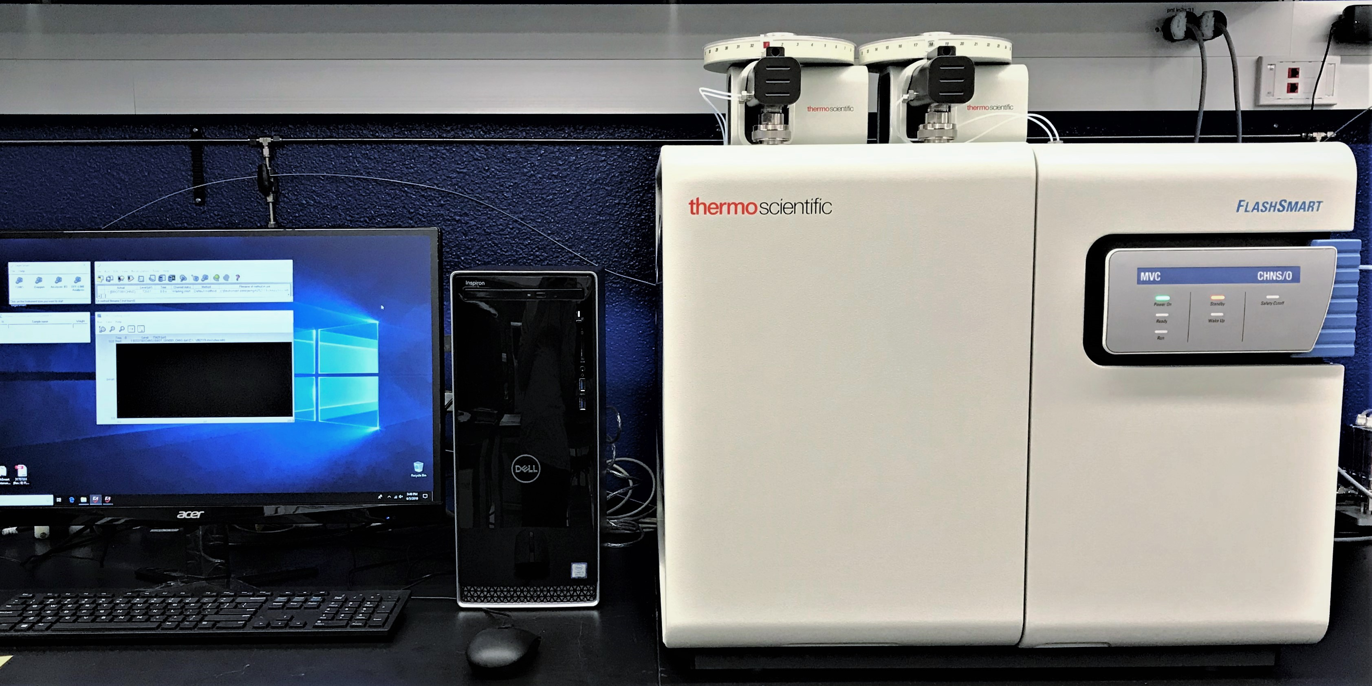
Thermo Scientific FlashSmart CHNS/O Elemental Analyzer

b) Elemental Composition Measurements: A state-of-the-art Thermo Scientific™ iCAP™ RQ Inductively Coupled Plasma Mass Spectrometer offers ultra-trace elemental analysis at sub-ppb to ppt levels and provides elemental screening in minutes. The coupled laser ablation system with a 193 nm pulsed excimer laser allows for solid sample introduction and surface elemental profiling. A Thermo Scientific FlashSmart CHNS/O Elemental Analyzer provide combustion and pyrolysis based quantitative elemental determination of carbon, hydrogen, nitrogen, sulfur, and oxygen.
c) Mechanical Property Measurements: A combination of a TA Instruments dynamic mechanical analyzer Q800 and an Instron 3365 Universal Testing System are capable of measuring mechanical properties of soft materials, liquids, formulations, and composites by introducing force from as little as 0.0001 N up to 50,000 N.

d) Physical Property Measurements: A Waters ACQUITY Advanced Polymer Chromatography (APC) System fractionates and characterizes polymers and nanomaterials with in-series coupled Wyatt µDAWN multi-angle light scattering (MALS) and Optilab UT-rEX refractive index detectors providing fast and accurate determination of particle sizes and distributions, absolute molecular weights of polymers, and even 3D geometric features of synthetic or natural macromolecules across a broad range of molecular weights (3000 ~ 2,000,000 g/mol). A combined set of 3Flex surface area analyzer and AccuPyc gas pycnometer from Micromeritics offers fully automated analyses of materials volume, surface area, mesopore and micropore size and distribution, static chemisorption, dynamic chemisorption, heat of adsorption, and vapor adsorption.
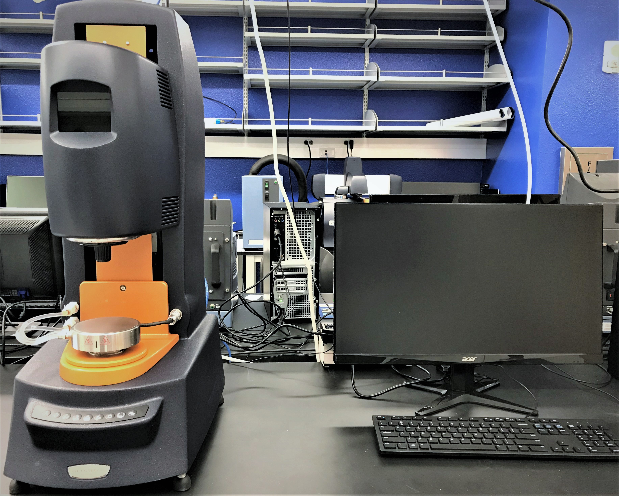
TA Instruments HR-2 Hybrid Rheometer
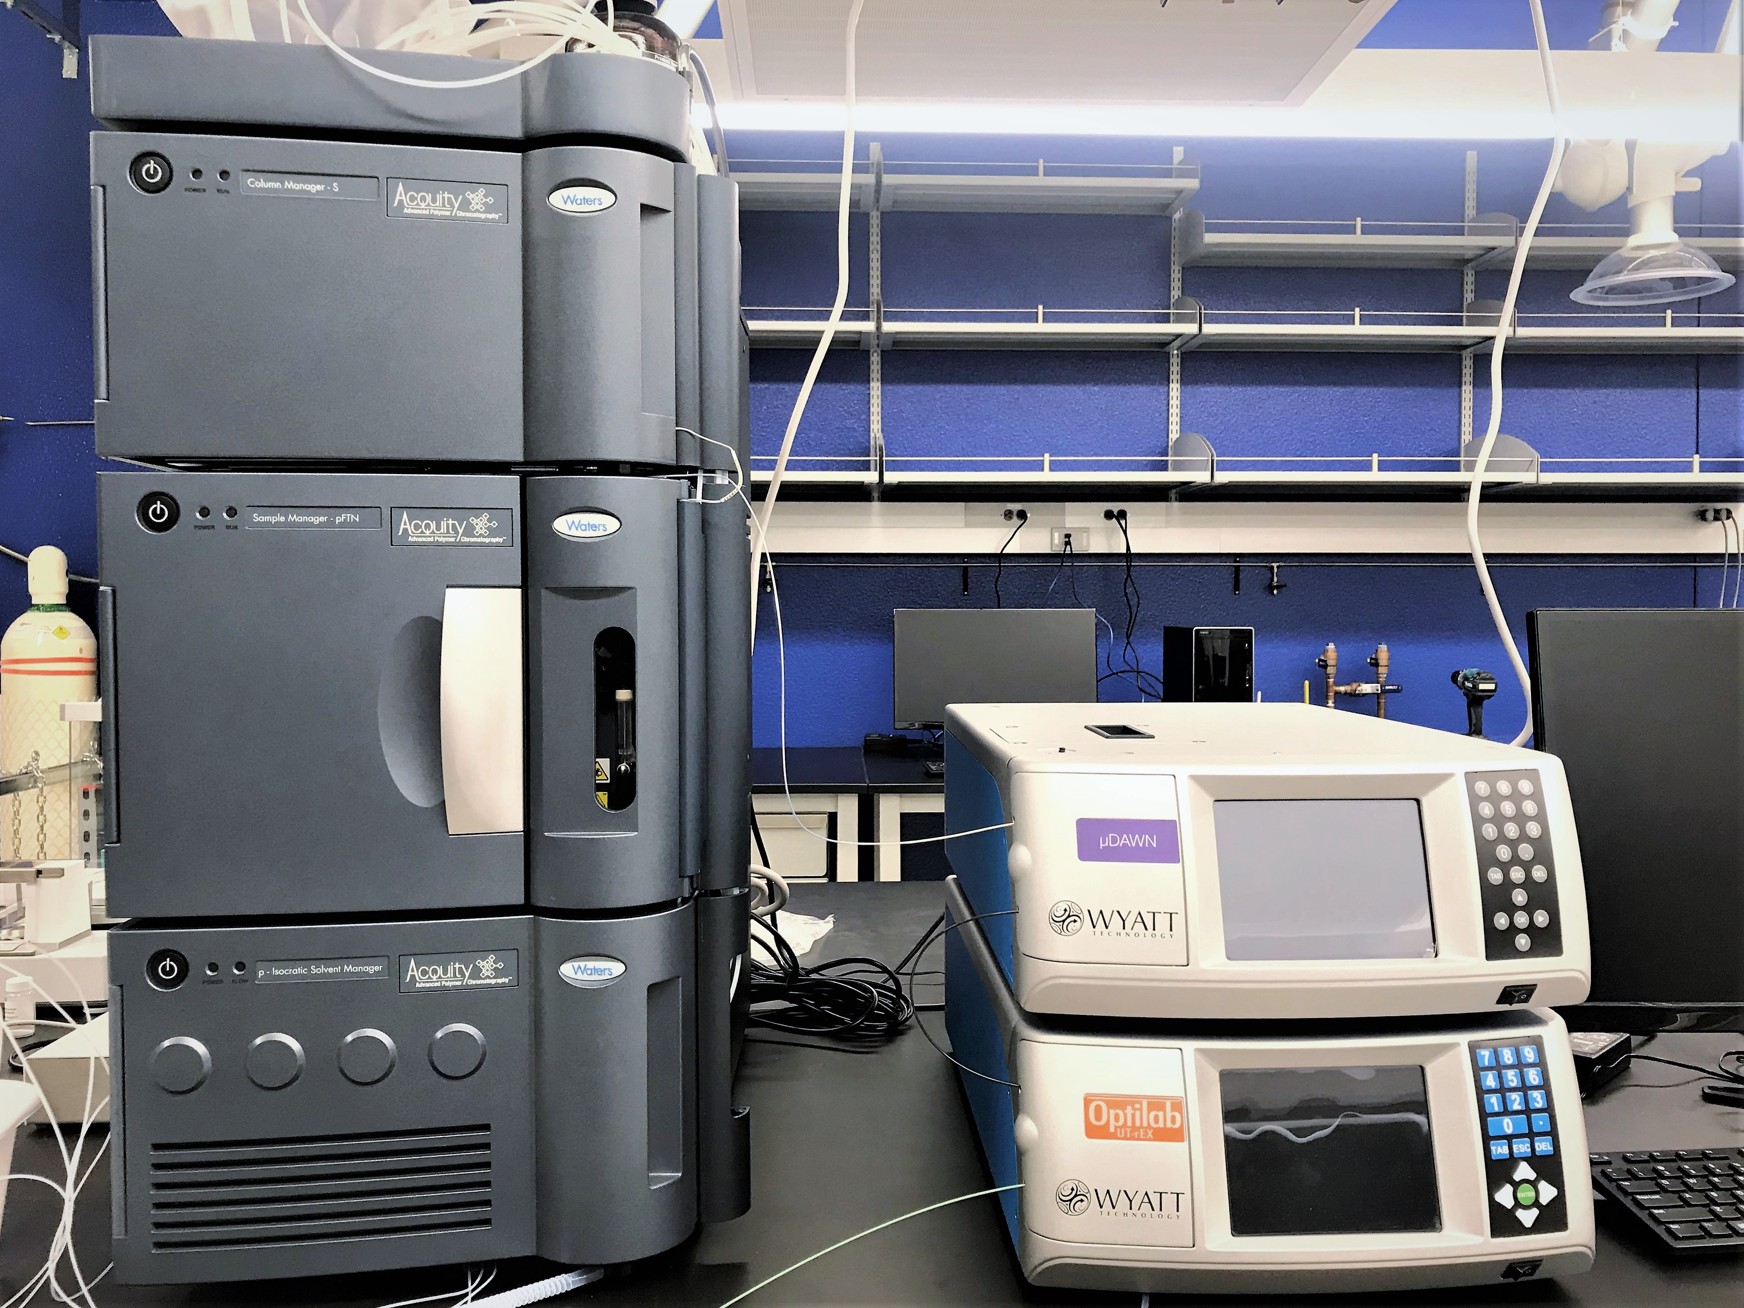
Waters ACQUITY APC with MALS and RI Detectors

e) Rheological property measurements: A Discovery series HR-2 hybrid rheometer from TA Instruments offers precise measurements of both viscosity and viscoelasticity of various materials such as high viscosity fluids, pastes, polymer solutions and melts, and soft solids and as a function of temperature.

Here is a summary if you want to have less text:
An overview of relevant equipment for this project follows:
Electron Microscopy. IMRI has five Transmission Electron Microscopes (TEM): 1) Nion UltraSTEM 200 HERMES, 2) JEOL Grand ARM300CF TEM/STEM, 3) JEM-2800 Transmission Electron Microscope, 4) JEOL-2100F-Cryo-TEM, and 5) FEI/Philips CM-20 conventional TEM; and four Scanning Electron Microscopes-Focused Ion Beams (SEM-FIBs): 1) TESCAN GAIA-3 GMH integrated focused ion beam-FESEM, 2) FEI Magellan 400 XHR SEM, 3) FEI Quanta 3D FEG Dual Beam (SEM/FIB), and 4) FEI XL-30 FEGSEM. The FEI Quanta may be operated under different vacuum modes, including environmental (ESEM). The FEI Magellan has sub-nanometer resolution and includes a new generation EDS system from Oxford Instruments (80mm² detector with AZtec software) and Nabity NPGS (nanometer pattern generation system), and is capable of light element analysis and fast elemental mapping.
X-ray Diffractometers (XRD). IMRI has two XRDs: 1) Rigaku SmartLab XRD and 2) Rigaku Ultima III Powder XRD, both have small-angle X-ray scattering capabilities.
X-ray Photoelectron Spectroscopy (XPS). AXIS Supra by Kratos Analytical is a high performance multi-technique surface science instrument combining high-sensitivity X-ray photoelectron spectroscopy (XPS) with Al/Ag monochromatic X-ray source, high resolution Auger electron spectroscopy (AES), ultraviolet photoelectron spectroscopy (UPS), and ion scattering spectroscopy (ISS). The Supra is capable of fast imaging XPS and AES with a spatial resolution as high as 1.0 and 0.1 micron, respectively. The system is equipped with a multi-mode monatomic Ar+ and Arn+ gas cluster ion source (GCIS) for state-of-the-art sputter cleaning and depth profiling of any inorganic or organic material, conductive or insulating. The analysis chamber is outfitted with a charge neutralization gun, sample cooling/heating (-100°C to 800°C, and up to 1000°C for short periods), and gas dosing. A UHV sample preparation chamber attached to the analysis chamber provides additional features including sample cooling/heating, ion etching, gas dosing, crystal cleaver, 4-pocket e-beam evaporator, and sample storage dock. In addition, an integrated glove box enables air-free sample fabrication, preparation, and transfer to the Supra’s UHV preparation chamber. The Supra has unparalleled automation and user-friendly software for data acquisition and processing.
Atomic Force Microscopy (AFM). IMRI manages a PNI Nano-R AFM which can image an object's surface topography with extremely high magnifications, up to 1,000,000X. The magnification is made in three dimensions, the horizontal X-Y plane and the vertical Z dimension. The scanning range is 90 microns in the X-Y plane and 8 microns in the Z-dimension. The resolution is better than 2 nm in the X-Y plane and 0.13 nm in the Z-dimension. The AFM can be operated under various imaging modes for different materials surfaces, such as Contact Mode and Close-Contact Mode. Besides imaging, the AFM is capable of measuring material surface properties using other operation modes, for example, Lateral Force Mode, Material Sensing Mode, and Force/Distance.

[More info and additional equipment found here: https://www.imri.uci.edu/content/imri-facilities]

